Number Guessing Game

Project Overview
The Number Guessing Game is a simple console-based Java application where the computer randomly selects a number between 1 and 100. The player attempts to guess the number, and the program provides feedback after each guess, indicating whether the guess is too high, too low, or correct.
This project demonstrates the use of:
- Random number generation
- Loops
- Conditional statements
- User input handling
- Basic game logic

Objective
The objective of this project is to:
- Generate a random number.
- Allow the user to enter guesses.
- Provide hints based on the user's input.
- Count the number of attempts taken to guess the correct number.
- Display a success message when the user wins.

Technologies Used
Technology | Purpose
Java | Programming Language
Scanner Class | User Input
Random Class | Random Number Generation
Console | User Interface

System Requirements

Hardware Requirements
- Any computer with at least 2 GB RAM
- Keyboard for user input

Software Requirements
- Java Development Kit (JDK 8 or above)
- Any Java IDE (Eclipse, IntelliJ IDEA, NetBeans) or Command Prompt

Algorithm
- Start the program.
- Generate a random number between 1 and 100.
- Initialize the attempt counter to 0.
- Ask the user to enter a guess.
- Increment the attempt counter.
- Compare the guess with the secret number:
  - If guess is less than the secret number, display "Too Low".
  - If guess is greater than the secret number, display "Too High".
  - If guess matches the secret number, display a success message.
- Repeat steps 4–6 until the correct number is guessed.
- Display the total number of attempts.
- End the program.

Program Flowchart
Start
|
v
Generate Random Number
|
v
Enter Guess
|
v
Guess == Secret Number?
/ \
No Yes
| |
v v
Too High/Low Display Success
| |
+------<-------+
|
v
End

Code

import java.util.Random;

import java.util.Scanner;

public class NumberGuessingGame {

public static void main(String[] args) {

Scanner scanner = new Scanner(System.in);

Random random = new Random();

int secretNumber = random.nextInt(100) + 1; // 1 to 100

int guess;

int attempts = 0;

System.out.println("=== Number Guessing Game ===");

System.out.println("I have chosen a number between 1 and 100.");

do {

System.out.print("Enter your guess: ");

guess = scanner.nextInt();

attempts++;

if (guess < secretNumber) {

System.out.println("Too low!");

} else if (guess > secretNumber) {

System.out.println("Too high!");

} else {

System.out.println("Correct! You guessed it in " + attempts + " attempts.");

}

} while (guess != secretNumber);

scanner.close();

}

}

Source Code Explanation

Import Statements

import java.util.Random;
import java.util.Scanner;
- Random generates a random number.
- Scanner reads user input from the keyboard.

Random Number Generation
int secretNumber = random.nextInt(100) + 1;
Generates a number between 1 and 100.

User Input
guess = scanner.nextInt();
Reads the user's guessed number.

Loop
do {
...
} while (guess != secretNumber);
Repeats until the correct number is guessed.

Conditional Statements
if (guess < secretNumber)
Checks if the guess is too low.
else if (guess > secretNumber)
Checks if the guess is too high.
else
Executes when the correct number is guessed.

Output

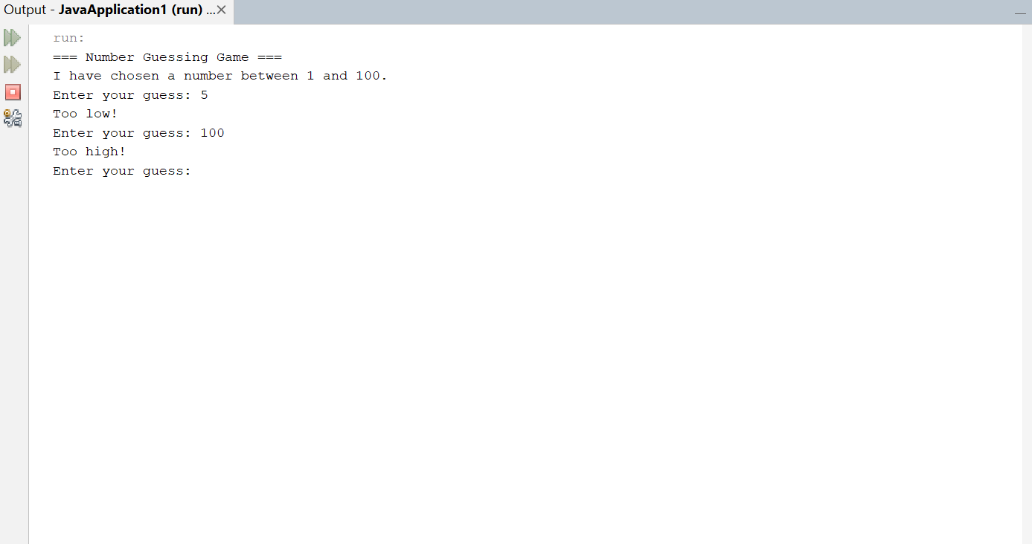

Features
- Random number generation
- Unlimited guessing attempts
- Hint system (Too High / Too Low)
- Attempt counter
- Simple and user-friendly interface

Advantages
- Easy to understand and implement
- Helps beginners learn Java fundamentals
- Demonstrates problem-solving techniques
- Interactive console application

Future Enhancements
- Add difficulty levels (Easy, Medium, Hard)
- Limit the number of attempts
- Add score calculation
- Create a graphical user interface (GUI)
- Store high scores in a file or database
- Add multiplayer mode
Conclusion
The Number Guessing Game is a beginner-friendly Java project that demonstrates key programming concepts such as loops, conditional statements, random number generation, and user interaction. It serves as an excellent project for students learning Java and provides a foundation for building more advanced games.

